
There were many different Indian tribes in the American West, each with their own set of beliefs and customs. What united them all were the consequences of American migration West.

Getting to know … the Cheyenne

https://www.ducksters.com/history/native_americans/cheyenne_tribe.php // https://en.wikipedia.org/wiki/Dog_Soldiers
Where did they live?  Montana:  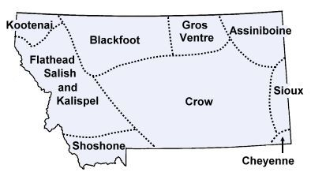  Nebraska:  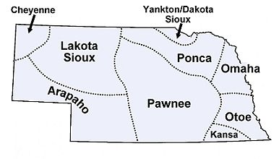  Answer: | What did they live in?  What language did they speak?  What food did they eat?  Who were their allies?  Who were their enemies? | The most famous of the Cheyenne warrior societies was:  Dog Soldiers:

Ceremony spotlight: The Sun Dance: https://en.wikipedia.org/wiki/Sun_Dance
Why was a sun dance held: | What happened during a sun dance: | Why did the US ban the sun dance and other religious ceremonies?

Cheyenne Wall of Fame
https://amazingwomeninhistory.com/buffalo-calf-road-cheyenne-warrior-woman/ // https://www.nps.gov/sand/learn/historyculture/black-kettle-biography.htm
Buffalo Calf Road Woman | Black Kettle
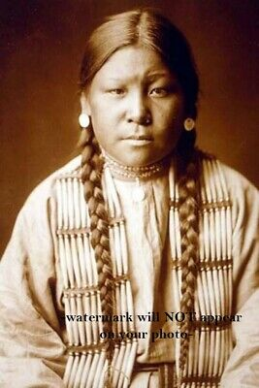  Why was Buffalo Calf Road Woman famous? | 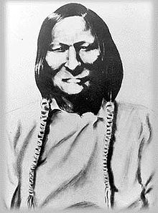  Why was Black Kettle famous?:

