
There were many different Indian tribes in the American West, each with their own set of beliefs and customs. What united them all were the consequences of American migration West.

Getting to know … the Cherokee
https://www.ducksters.com/history/native_american_cherokee.php // https://nativeamericans.mrdonn.org/southeast/cherokee/battletechniques.html
Where did they live?  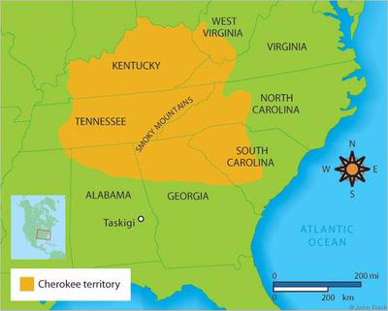 | How did they travel before the Europeans brought horses?  How many people would live in a Cherokee village?  How did the Cherokee lose land in the 1700s?  What was the Trail of Tears and why did it happen? | What techniques did Cherokee warriors use in battle?

Ceremony spotlight: The Stomp Dance: http://www.northerncherokeenation.com/the-stomp-dance.html
Why would they hold a Stomp Dance? | What happened during the ceremony: | What would they wear to a Stomp Dance?

Sioux Wall of Fame
https://www.nyhistory.org/sites/default/files/newfiles/cwh-curriculum/Module%202/Life%20Stories/Nancy%20Ward%20Life%20Story.pdf // https://www.ducksters.com/history/native_americans/sequoyah.php
Nancy Ward | Seqoyah
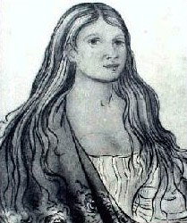  What was a Beloved Woman?  Why was she famous? | 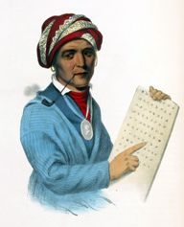  Why was he famous?

